Woke Coliving Reservation and Management System

A Thesis Presented to
Kolehiyo Ng Subic

In Partial Fulfilment
of the requirements for the Degree of
Bachelor of Science in Computer Science
By:
Stephen Zhane B. Begosa
Fredhenzel N. Tayson
Bryan Louie S. Ablao

Bartolome H. Javillonar Jr., MAT
Thesis Adviser

April

ADVISER’S RECOMMENDATION SHEET

This thesis entitled
Woke Coliving Reservation and Management System
By:
Stephen Zhane B. Begosa
Fredhenzel N. Tayson
Bryan Louie S. Ablao

Submited in Partial Fullfilment of the requirements of the Bachelor of Science in Computer Science degree has been examined and recommend for acceptance and approval.

Mr. Bartolome H. Javillonar Jr., MAT

April 2026

THESIS COORDINATOR AND DEAN ACCEPTANCE SHEET

This thesis entitled
Woke Coliving Reservation and Management System

After having been recommended and approval is hereby accepted by the Computer Studies Department of Kolehiyo Ng Subic

_______________________________
Thesis Coordinator

_______________________________
Mrs. Jennifer Miro Asuncion, MBA
CSD Chairperson

April 2026

PANEL’S APPROVAL SHEET

This Thesis Proposal Entitled
Woke Coliving Reservation and Management System
Developed By:
Stephen Zhane B. Begosa
Fredhenzel N. Tayson
Bryan Louie S. Ablao

After having been presented is hereby approved
by the following members of the panel

Table of Contents

Thesis Title Page
Adviser’s Recommendation Sheet
Thesis Coordinator and Dean’s Acceptance Sheet
Panel’s Approval Sheet
Table of Contents
Abstract
Chapter 1 Introduction
  - Background of the Study ................................................................
  - Statement of the Problem ................................................................
    - General Problem ......................................................................
    - Specific Problem ......................................................................
  - Objective of the Study ......................................................................
    - General Objective ....................................................................

ABSTRACT
In the wake of rising urban housing costs and the growth of the "digital nomad" workforce, coliving has emerged as a sustainable housing solution. This project presents the development of the Woke Coliving Reservation and Management System, an integrated digital platform designed to streamline high-density residential operations. Unlike traditional property management software, this system addresses the specific complexities of coliving, including flexible short-to-long-term leasing, bed-level inventory tracking, and communal resource scheduling. The system features a dual-interface architecture: a user-centric web portal for residents to manage bookings, digital payments, and service requests, and a robust administrative dashboard for real-time occupancy monitoring and automated billing. By automating the "move-in/move-out" workflow and centralizing tenant data, the platform aims to reduce administrative overhead by approximately 40% while enhancing the resident experience through seamless digital interaction. Preliminary evaluations suggest that the system significantly mitigates common operational bottlenecks, such as manual booking conflicts and delayed maintenance response times.

Keywords: Coliving, Property Management System (PMS), Automation, Urban Housing, Digital Transformation.

Chapter 1
Introduction
In the modern digital landscape, computer-based systems have evolved from a luxury to a necessity for efficient business management. By automating core operations like booking and billing, these tools provide a structured framework for organizing data, accelerating transaction speeds, and maintaining high levels of operational accuracy. For high-density housing providers like dormitory spaces, transitioning to digital infrastructure is vital for effectively managing the complexities of room availability, tenant reservations, and financial tracking.
Woke Coliving Inc., a Mandaluyong-based establishment founded in 2021, currently faces significant operational hurdles due to its reliance on manual processes and social media-based inquiries. To eliminate common issues such as booking conflicts and delayed payments, the company is shifting toward a dual-system digital strategy: a Dormitory Reservation Website for real-time online bookings and a Dormitory Billing System for automated financial management. Together, these systems will modernize the tenant experience, reduce human error, and provide the company with a more reliable, scalable foundation for growth.
The first pillar of this strategy is the Dormitory Reservation Website, designed to facilitate real-time online bookings and provide prospective tenants with an immediate, transparent view of available inventory. Complementing this is the Dormitory Billing System, a backend solution dedicated to automating financial management and streamlining the collection of monthly dues. By integrating these two modules, Woke Coliving aims to modernize the end-to-end tenant experience and drastically reduce the risk of human error. Ultimately, this digital overhaul will provide the company with a more reliable, data-driven, and scalable foundation to support its future expansion in the competitive coliving market.

1.1 Backround of The Study
Woke Coliving Inc. was founded in 2021 to provide affordable and community-oriented housing solutions. Located at 205 Kanlaon St, Highway Hills, Mandaluyong City, the company offers dormitory spaces designed for modern urban dwellers. As the company continues to grow, managing reservations and billing manually has become increasingly difficult.
The dormitory space consists of 53 rooms with a total of 233 beds, configured as 4-bed or 6-bed bunk beds. Each room has a private toilet and shower, while tenants share a common pantry, lobby, and lounge. The company also offers free Wi-Fi and dedicated parking slots, with 5 slots for cars and 5 slots for motorbikes.
The 1st floor of the building serves as the lobby, while the rooms are distributed across the 2nd to 7th floors, with 9 rooms per floor. The room numbers range from 201 to 209 on the 2nd floor, continuing similarly up to the 7th floor (701 to 709).
Currently, tenants book rooms through the company’s Facebook Page, phone calls, and in-person (walk-in) inquiries, while administrators record bookings and payments using logbooks and spreadsheets. This manual system is not only time-consuming but also prone to errors. Booking conflicts, delayed payment tracking, and inconsistent records often lead to tenant dissatisfaction and administrative challenges.
The reliance on manual record-keeping has led to several operational inefficiencies that threaten the company’s growth. Frequent booking conflicts, such as accidental double-bookings or inconsistent availability updates, often result in tenant dissatisfaction. Furthermore, tracking payments manually is prone to human error, leading to delayed financial reporting and disorganized records. To maintain its reputation for excellence, Woke Coliving Inc. faces the urgent need to transition toward a digital management solution that can streamline reservations and billing.

1.2 Statement of the Problem
1.2.1 General Problem
Woke Coliving Inc. currently faces operational challenges due to a heavy reliance on manual processes for tracking room availability and tenant data. This dependency often leads to booking conflicts and significant delays in administrative workflows. To address these inefficiencies, the Woke Coliving Reservation and Management System has been designed to automate core operations, ensuring a seamless booking experience and more organized data oversight.
1.1.2 Specific Problem
- Real-Time Inventory Discrepancies
Manual tracking often leads to a "lag" between a room being booked and the record being updated. This results in double-bookings or "ghost vacancies," where a room appears available on paper but is already occupied, leading to tenant dissatisfaction and lost revenue.
- Fragmented Maintenance and Room Turnaround
When a tenant moves out, there is often no automated trigger to alert maintenance or cleaning crews. A manual system relies on verbal or text-based communication, which can cause rooms to sit empty and "unready" for longer than necessary, reducing the inventory's turnover efficiency.
- Difficulty in Managing Short-Term vs. Long-Term Stays
Manually juggling different lease terms ( daily, weekly, or monthly) across various room types often leads to scheduling gaps. A lack of automated "blocking" for maintenance or transition periods between different stay lengths can result in rooms being unready for guests arriving.
- Inconsistent Key Management and Access Logs
A manual system often lacks a digital audit trail for room keys or access codes. This creates security vulnerabilities, as there is no centralized record of who has accessed specific units or when keys were issued and returned, increasing the risk of unauthorized entry.
1.3 Objective of the study
1.3.1 General Objective
This study aims to implement the Woke Coliving Reservation and Management System, a digital solution tailored to optimize occupancy and administrative efficiency. By automating the reservation workflow and centralizing resident data, the system provides a holistic approach to coliving oversight.
1.3.2 Specific Objective
- To provide detailed monthly occupancy and revenue analytics to help management make data-driven decisions regarding pricing and facility upgrades.
- To enhance data accuracy by synchronizing payment records with the reservation calendar to prevent double-booking or missed rental collections.
- To provide a centralized real-time dashboard that displays room availability, pending maintenance requests, and upcoming lease expirations to streamline daily property management.
- To enhance financial transparency by providing residents with a downloadable history of all past payments, invoices, and miscellaneous charges.
- To provide a visitor management feature that allows residents to pre-register guests and generate temporary entry codes for enhanced security.

1.4 Scope and Limitations
1.4.1 Scope
The Woke Coliving Reservation and Management System is an all-in-one platform for residents and admins. It features a user centric booking engine for browsing rooms and signing digital leases, alongside an administrative dashboard that automates billing, tracks occupancy, and manages maintenance requests in real-time.

- Log In:
The Woke Coliving Reservation and Management System is an all-in-one platform for residents and admins. It features a user centric booking engine for browsing rooms and signing digital leases, alongside an administrative dashboard that automates billing, tracks occupancy, and manages maintenance requests in real-time.
- Management Dashboard:
To tailor this for a Woke Coliving Reservation and Management System, we need to shift the focus from residents and households to members, occupancy, and revenue, while distinguishing between the high-level oversight of a Super Admin and the operational focus of an Admin.
- Room Management:
The system features a digital storefront that displays available rooms, tiered pricing, and specific unit numbers across all seven floors to provide a transparent property overview.
- Reservation Record Management:
The system offers an administrative interface for property managers to oversee tenant stays, modify lease details, and manage reservation requests in real-time.
- Expense Tracking:
The system incorporates a specialized financial oversight module that empowers administrators to meticulously document every operational cost, categorize outgoing funds, and maintain a real-time audit trail of all company expenditures to ensure fiscal transparency and long-term budget stability.
- Utilities Management:
The Woke Coliving Reservation and Management System features an integrated utility module that tracks real-time consumption to automate billing and provide residents with transparent cost breakdowns.
- Reports:
The Woke Coliving Reservation and Management System uses a high-level analytics engine to generate detailed reports on reservations, payments, and utilities for better strategic planning and financial monitoring.
1.4.2 Limitations
The system is exclusively designed for the Makati (Poblacion) branch. It will not process reservations, inventory, or room assignments for the Mandaluyong or Banahaw locations. The system will not store, process, or transmit credit card data directly no PCI-compliant payment gateway).
1.5 Significance of the study
The proposed system will benefit the following stakeholders:
- Super Admin and Admin
The Woke Coliving Reservation and Management System streamlines the booking process to reduce administrative workload and ensure accurate tenant records.
- Tenants:
Tenants can conveniently book rooms online through the website, phone calls, or in-person (walk-in) inquiries. They will also receive instant booking confirmations and access to their billing statements, including water, electricity, and parking fees.
- Management:
The system will provide real-time tracking of utilities, payments, and company expenses, including room-specific data for the 9 rooms per floor, from 201–209 on the 2nd floor up to 701–709 on the 7th floor, with the 1st floor serving as the lobby.
- Future Researchers:
The Woke Coliving Reservation and Management System provides a specific architectural framework for researching IoT-enabled utility monitoring and automated digital leasing in seven-floor urban housing models.
- Customer:
The Woke Coliving Reservation and Management System integrate management system eliminates the friction of traditional renting, providing you with real-time room availability, automated billing, and a direct digital line for maintenance requests and support.

Chapter 2
Theoretical Framework
2.1 Introduction
The purpose of this research is to develop the Woke Coliving Reservation and Management System. This system aims to improve the management of room reservations, tenant payments, and utility tracking. This chapter contains the theories, review of related literature, methodology used in building the proposed system, and the Input-Process-Output (IPO) chart.
The following sections discuss the development of the system and review related research covering reservation systems, billing automation, and utility tracking in both local and international studies. The discussion highlights key technological advancements and their impact on operational efficiency.
2.2 Completed IPO Chart
Input |  | Process |  | Output
Reservation Details  * Tenant Name  * Check-in Date  * Room Type  * Number of Occupants |  | Process reservation and assign room |  | Reservation confirmation & room assignment
Payment Information  * Payment Method  * Amount  * Due Date |  | Process payments and validate transactions |  | Payment confirmation & receipts
Billing Details  * Monthly Rent  * Water & Electricity  * Parking Fees |  | Calculate monthly fees and generate bills |  | Generated monthly bill statements
Tenant Requests  * Special Requests  * Maintenance Requests |  | Track requests and update records |  | Processed requests and status updates
Expense Tracking |  | Track expenses and generate financial reports |  | Expense reports & tenant balance summary

2.3 Woke Coliving Reservation and Management System
A Woke Coliving Reservation and Management System is a digital platform that streamlines tenant reservations, payment tracking, and expense management. This system will allow administrators to monitor room occupancy, track utility usage, and automate the generation of invoices. The web-based platform ensures efficient room booking, financial tracking, and utility monitoring, reducing the risk of double bookings and incorrect billings. Additionally, it helps maintain an organized financial record-keeping system, ensuring accuracy and transparency in all transactions.
Reference: Spacebring. (2024). Automating Payments & Invoicing in Coworking Spaces. Retrieved from https://www.spacebring.com/blog/productivity/coworking-space-billing
2.3 User Interface and Experience in Coliving Systems
The User Interface (UI) and User Experience (UX) of the Woke Coliving Reservation and Management System play a crucial role in ensuring ease of use, accessibility, and efficiency. A well-designed graphical user interface (GUI) allows tenants and administrators to navigate the system seamlessly, manage reservations, monitor billing, and access utilities without technical difficulties.
Reference: Nielsen, J. (2023). The Role of UI/UX in Digital Housing Platforms. Retrieved from https://www.nngroup.com

2.4 Online Room Reservation System
The online room reservation system enables real-time booking and availability updates, ensuring that tenants can secure their accommodations conveniently. This system eliminates double bookings and allows administrators to manage reservations efficiently.
Reference: OfficeRnD. (2023). Automate Booking and Reservation Management. Retrieved from https://www.officernd.com/coworking-software/billing-and-payments
2.5 Digital Payment Integration
Integrating digital payment methods into the Woke Coliving Reservation and Management System allows tenants to pay dues via online transactions, increasing convenience and reducing late payments. This feature ensures secure and efficient financial transactions.
Reference: MangoBeds. (2022). The Future of Digital Booking Systems for Coliving. Retrieved from https://www.mangobeds.com/
2.6 Data Security and Privacy Protection
A key concern for any digital system is data security and privacy. The Woke Coliving Reservation and Management System incorporates encryption, access control, and secure backups to ensure tenant data remains protected.
Reference: CORE. (2023). Theoretical Approaches to Data Security. Retrieved from https://core.ac.uk/download/pdf/132799031.pdf
2.7 Automated Expense TrackingThe automated expense tracking module of the system records all financial transactions, utility costs, and maintenance fees in real time. This feature provides accurate financial reports and improves administrative efficiency.
Reference: Petromo. (2023). Inventory Management for Gas Stations and C-Stores: A Beginner’s Guide. Retrieved from https://www.petromo.com/inventory-management-for-gas-stations-and-c-stores-a-beginners-guide/
2.8 Smart Utility Monitoring System
By integrating submetering technology, the Woke Coliving Reservation and Management System ensures that electricity and water consumption are accurately divided among tenants, making utility billing more transparent and fair.
Reference: Res:Harmonics. (2023). How Technology is Shaping the Future of Coliving. Retrieved from https://www.resharmonics.com/blog/coliving-in-2033-how-technology-is-shaping-the-future-of-coliving
2.9 Automated Maintenance Request System
The Woke Coliving Reservation and Management System includes an automated maintenance request module that allows tenants to submit repair requests digitally. This ensures that administrators can efficiently assign tasks to maintenance personnel, track the status of requests, and reduce downtime for essential repairs.
Reference: FacilitiesNet. (2023). How Digital Maintenance Systems Improve Facility Management. Retrieved from https://www.facilitiesnet.com
2.10 Cloud-Based Property Management Systems
Cloud-based systems improve property management by enabling real-time data access, remote administration, and automated backups. These systems allow coliving operators to manage bookings, billing, and tenant records efficiently while ensuring data security and accessibility.
Reference: RealPage. (2023). The Role of Cloud Computing in Property Management. Retrieved from https://www.realpage.com
2.11 The Impact of Automated Billing on Tenant Satisfaction
Studies show that automated billing systems significantly reduce late payments, improve transparency, and increase tenant satisfaction. Automated invoicing ensures that tenants receive accurate and timely billing state
ments, reducing disputes and improving financial management for property administrators.

2.12 User Acceptance Factors
Reference: PropertyWare. (2023). How Automated Billing Improves Tenant Retention. Retrieved from https://www.propertyware.com
The effectiveness and usability of a Woke Coliving Reservation and Management System determine its acceptance among tenants and administrators. Users are more likely to adopt a system if it is efficient, practical, and user-friendly. For example, a seamless booking interface with real-time updates enhances convenience, while an automated billing system ensures transparency in monthly dues and utility costs.
Reference: Nielsen, J. (2023). The Role of UI/UX in Digital Housing Platforms. Retrieved from https://www.nngroup.com
2.13 Role of IoT in Smart Utility Management
The Internet of Things (IoT) is revolutionizing utility management by allowing coliving spaces to track real-time electricity and water usage through smart meters. This technology ensures fair billing, improves energy efficiency, and reduces waste.
Reference: Energy.gov. (2023). Smart Metering and IoT in Energy Management. Retrieved from https://www.energy.gov
2.14 MySQL Database
MySQL is an open-source relational database management system that stores data in tables made up of rows and columns. Users can define, manipulate, control, and query data using Structured Query Language (SQL).

2.15 XAMPP
XAMPP (Cross-Platform, Apache, MySQL, PHP, and Perl) is a lightweight Apache distribution that allows developers to create a local web server for testing. It includes the Apache server, MySQL database, and PHP scripting language.
2.16 Visual Studio Code
Visual Studio Code (VS Code) is a source code editor supporting multiple programming languages such as JavaScript, Python, and PHP. It provides debugging, syntax highlighting, and Git integration.
2.17 PHP
(Hypertext Preprocessor) is an open-source, server-side scripting language used for web development. It enables developers to create dynamic applications and interact with databases like MySQL. 17 PHP
2.18 Waterfall Model
The proponent used the Waterfall Model as the methodology of the system. This is a linear and sequential software development approach where each phase must be completed before moving to the next.
Requirements: Information is gathered from the client, including business needs and existing processes.
Analysis and Design: The system architecture, database schemas, and user interfaces are designed.
Development: Actual coding and implementation of the system modules based on design specifications.
Testing: The system undergoes unit, integration, and user acceptance testing to resolve errors.
Deployment: The system is installed, configured for real-world use, and validated.
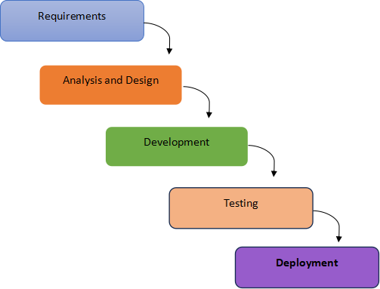

2.19 Summary
This chapter outlined the theoretical framework, development methodology, and literature review supporting the Woke Coliving Reservation and Management System. The use of the Waterfall Model ensures a structured approach in developing a fully automated, secure, and efficient platform. Through automated transactions and real-time monitoring, the system enhances the overall coliving experience while reducing administrative workload.
The system’s architecture is built upon a robust technical stack: Visual Studio Code served as the primary integrated development environment for writing and refining code, while PHP was utilized for server-side logic to ensure dynamic functionality. To manage data effectively, a MySQL database was implemented, all hosted and tested within the XAMPP local server environment. Through these essential technologies, the system enables automated transactions and real-time monitoring, ultimately enhancing the overall coliving experience while significantly reducing administrative workload.

Chapter 3
3.1 Introduction
The primary objective of the Woke Coliving Reservation and Management System is to provide Woke Coliving Inc. with a centralized and streamlined platform designed to handle complex administrative tasks with high efficiency. By transitioning from traditional practices to a digital infrastructure, the project ensures that the management of daily operations remains organized and scalable as the business grows.
To ensure the system addressed specific operational pain points, the proponent conducted a detailed examination of the company’s existing manual methods. This analysis allowed for the design of a specialized framework that automates key processes, such as recording multi-channel bookings and calculating utility consumption.
3.2 System Design and Specification
The Woke Coliving Reservation and Management System is designed to provide a comprehensive digital infrastructure for Woke Coliving Inc.. It focuses on automating core administrative tasks to enhance operational efficiency and data accuracy.

- Log-in: Includes a user ID and password for secure access; valid credentials are required for authentication.
- Main: Provides a centralized overview of coliving operations, allowing the administrator to manage modules such as reservations, billing, utilities, maintenance, and settings.
- File Management: Contains comprehensive data related to tenants, reservations, and utilities.
- Tenants: Enables adding and managing tenant information.
- Reservations: Records room bookings from multiple channels, including Facebook Messenger, phone calls, and walk-ins.

- Utilities: Tracks water charges per tenant and electricity consumption per room.
- Parking: Manages parking slots and tracks daily or monthly fees for cars and motorbikes.
- Expenses: Tracks maintenance and miscellaneous costs.
- Reports: Generates detailed reports on reservations, billing, utilities, and expenses.
- User Logs: Monitors system security by tracking the login and logout times of personnel.
- Database Backup and Restore: Ensures data recovery and protection against accidental deletion or system crashes.
- Admin Account: Allows for the management of administrative login credentials.
- Activity Log: Enables auditing of all actions performed within the system.
- Mian: This module pertains to the proposed system’s user side. This module pertains to the proposed system’s administrative side

Resources: The Woke Coliving Reservation and Management System requires the following hardware and software to operate effectively:
Hardware: Software:
- 2 GB RAM Memory Microsoft Windows 10
- Intel Core 2 Duo Processor Microsoft Office 2016
- USB Keyboard
- USB Mouse
- At least 200 GB HDD

3.3 Database Design
MySQL is utilized for the database design, structuring tables for tenant information, room details, reservations, payments, and utilities. It ensures data consistency and provides a reliable foundation for tracking room availability and monthly records.

3.4 Entity Relationship Diagram (ERD)
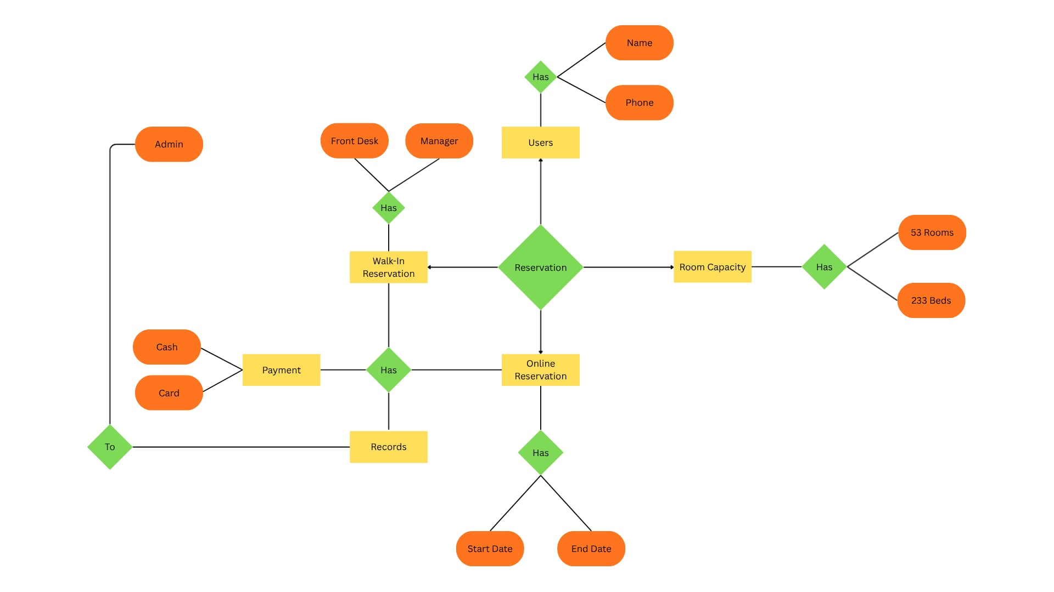

3.5 Data Flow Diagram
The Data Flow Diagram (DFD) illustrates how data flows through the Dormitory Reservation and Billing System, from room reservation to payment processing and report generation. It presents the processes such as receiving reservation requests from tenants, verifying room and bed availability, managing billing and utilities, and generating reports for the administrator. This ensures an organized and efficient workflow of input and output between the admin, staff, and tenants, allowing the system to operate smoothly and accurately.

3.5.1 Context Level Diagram

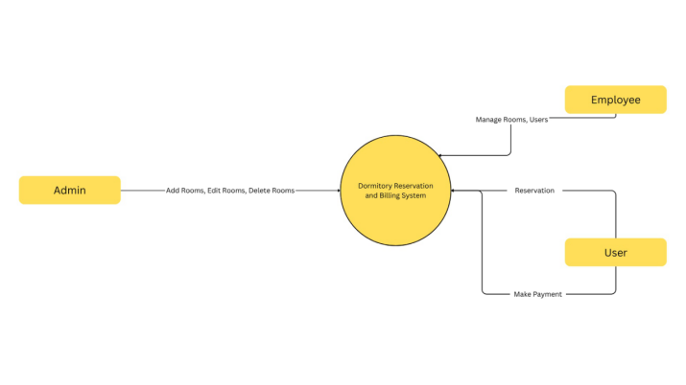

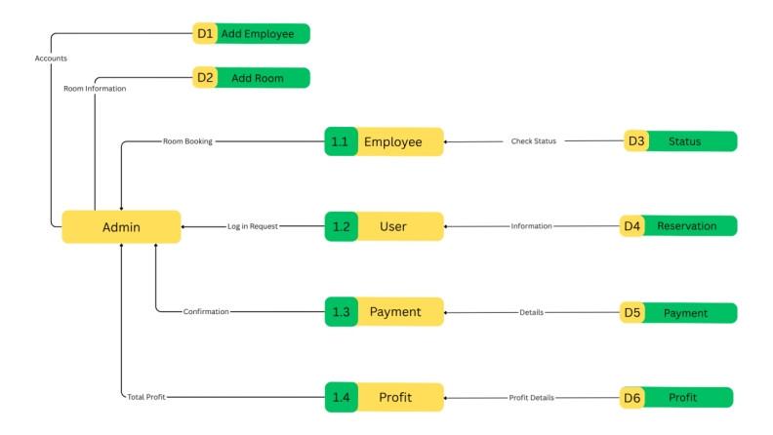
3.5.2 Top Level Diagram

3.5.3 Child Diagram
Child Diagram 1.0
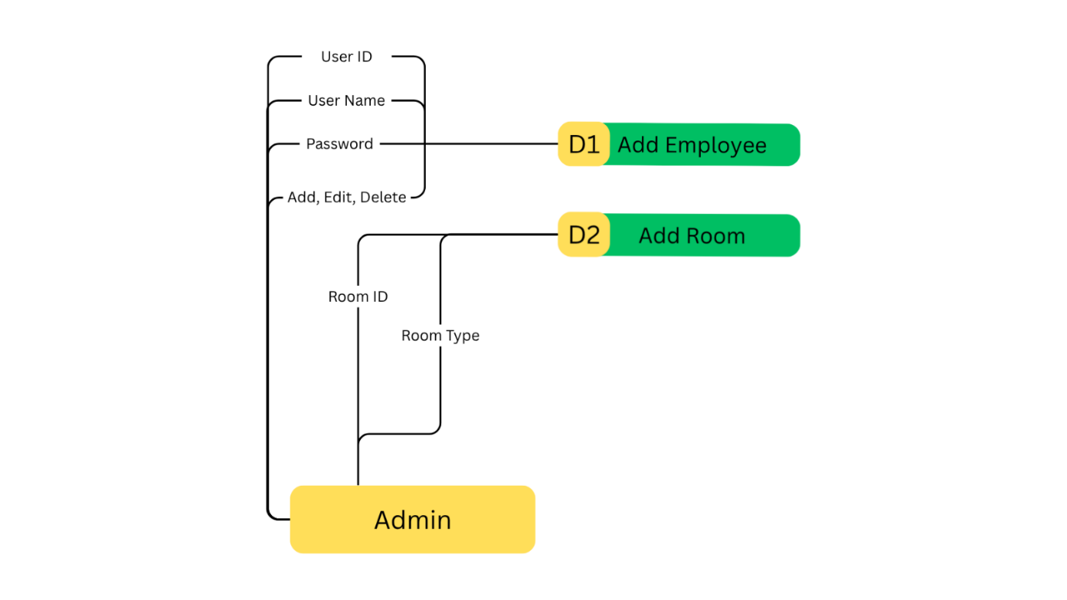

Child Diagram 2.0
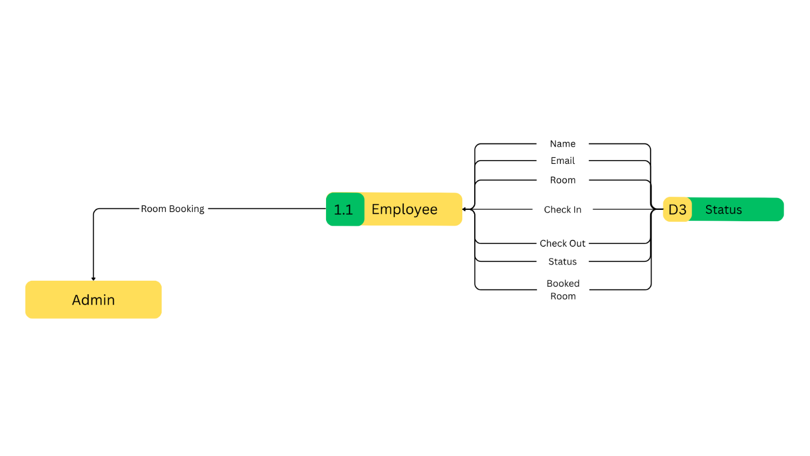

Child Diagram 3.0
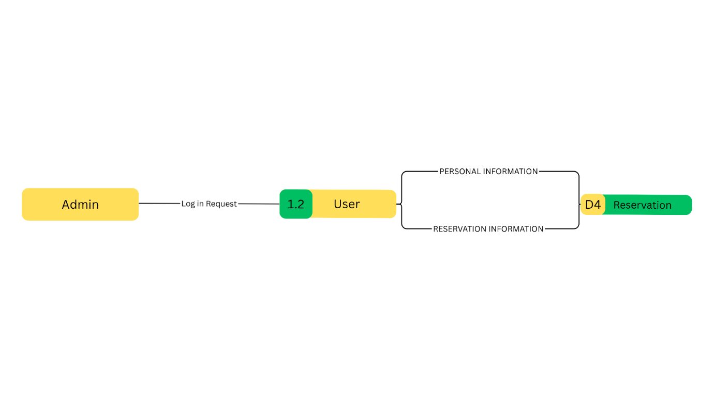

Child Diagram 4.0
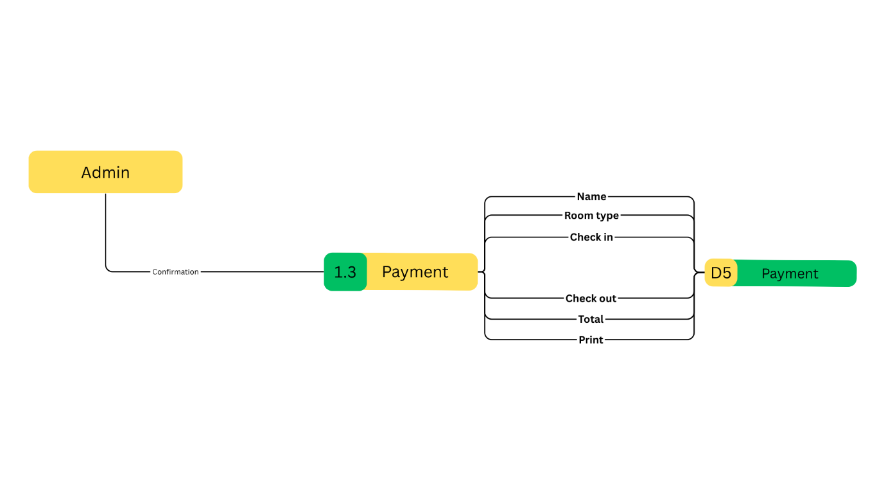

Child Diagram 5.0
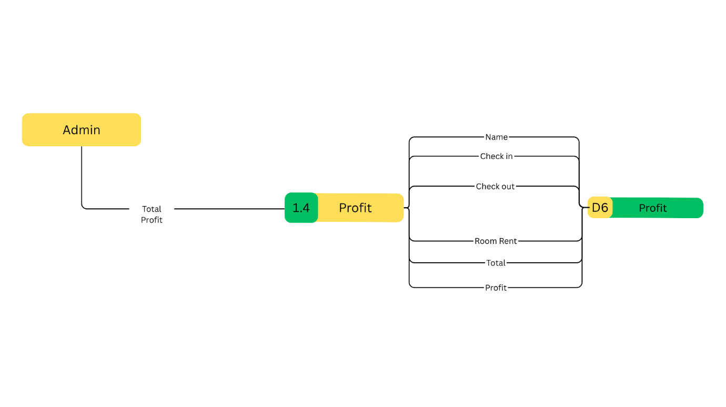
3.5.4 Heirarchical Diagram
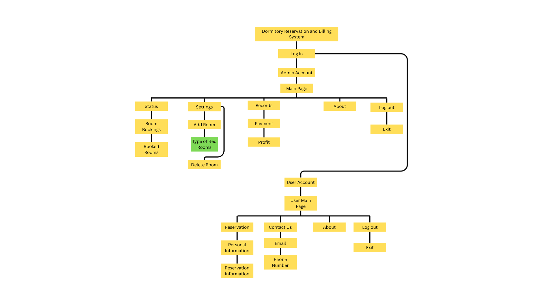

3.6 Summary
The Woke Coliving Reservation and Management System for Woke Coliving Inc. is designed to provide a comprehensive digital infrastructure for overseeing daily operations and tenant lifecycles. This system automates critical administrative tasks such as multi-channel reservation tracking, utility consumption monitoring, and the management of parking allocations and fees. By integrating these diverse operational elements into a unified platform, the system reduces reliance on manual record-keeping and enhances data integrity, ensuring that all management-related transactions and coliving expenses are tracked with precision and efficiency.

Chapter 4
Performance Analysis
4.1 Introduction
This chapter presents a comprehensive performance analysis of the "Woke Coliving Reservation and Management System." The primary objective is to evaluate how effectively the system meets its operational requirements and provides value to its stakeholders, including both potential tenants and the property management team.
4.2 Experimental
The performance analysis of the Woke Coliving Reservation and Management System includes several stages of testing, as follows:
4.2.1 Unit Testing
Unit testing is conducted at the early stages of development by programmers to validate that each unit of the Woke Coliving Reservation and Management System software functions as intended and aligns with the requirements for resident profiles, booking logic, and payment processing. The primary objectives of unit testing are to ensure the correctness of the code, test every function and procedure (such as room availability checks, pricing calculations, and data validations), and rectify any identified bugs and issues promptly. This phase is vital for cost-saving measures, as detecting and addressing errors early in development is more economical.
4.2.2 Integration Testing
Integration testing focuses on verifying the interactions and data exchange between different components of the system. It aims to ensure that various modules, such as the Frontend User Interface, the Backend Reservation Engine, and the External Payment Gateway ( Stripe) work together harmoniously, specifically testing scenarios like successful data transfer after a reservation and data synchronization across devices.

4.2.3 System Testing
System testing was conducted to evaluate whether the Woke Coliving Reservation and Management System meets the client’s specified requirements for a modern co-living operation. The overall behavior of the system was observed across all integrated modules, including property inventory checks, lease agreement processing, residents, resident profile management, billing generation, and record-keeping. The end-to-end user journey, from initial room search to final payment and confirmation, was meticulously evaluated for data accuracy and logical flow.
4.2.4 Stress Testing
The proponents performed stress testing to determine the system’s stability, reliability, and response to heavy operational loads. This process involved simulating multiple users accessing the system simultaneously (e.g., hundreds of concurrent room search queries or multiple simultaneous lease e-signatures) to ensure that the application, database, and third-party payment gateways remain stable, responsive, and within acceptable performance thresholds. Specific focus was given to critical transactions like room booking and payment processing during simulated peak traffic.
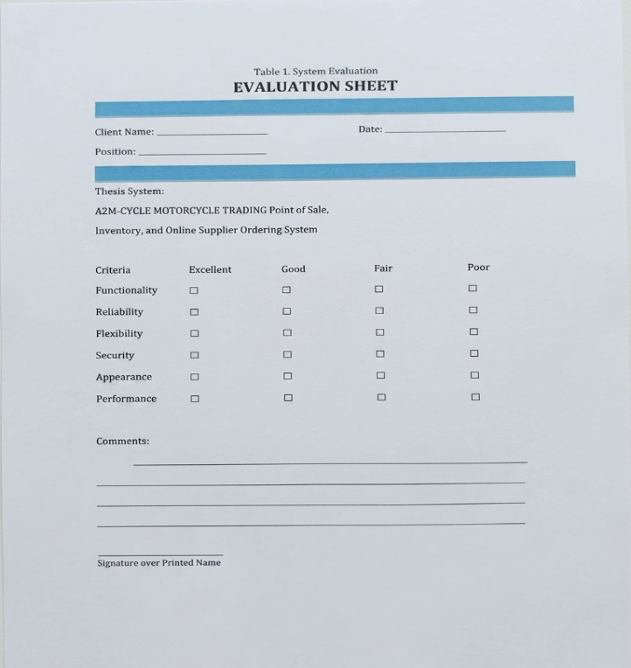
4.3 Result and AnalysisWoke Coliving Reservation and Management System Evaluation
Chapter 5
Conclusion and Recommendation
5.1 Conclusion
This thesis documentation has presented the Woke Coliving Reservation and Management System, which aims to revolutionize the management and operational processes of modern coliving establishments. The proposed system was developed specifically for Woke Coliving Inc. to replace traditional manual record-keeping methods commonly used in handling room reservations, resident profiles, lease agreements, and billing transactions.
The system was developed using a modern technology stack leveraging a dynamic web frontend, a robust backend application server, and a scalable database architecture resulting in an application that is efficient, accurate, and user-friendly for coliving administrators and staff.
The proposed system effectively manages resident profiles, diverse room inventories, lease terms, reservation records, and integrated billing information. It automates critical processes that were previously prone to human error, thereby improving the accuracy and reliability of operational data. By utilizing this system, daily coliving operations become more organized and transparent, ensuring that residents receive accurate billing and that administrators can easily monitor all property transactions.
This study emphasizes the critical importance of adopting computerized management systems in the rapidly evolving coliving industry. As society continues to embrace technological advancements, the Woke Coliving Reservation and Management System demonstrates how automation and integration can lead to more efficient, accurate, and reliable business operations, benefiting both property management and its residents.
5.2 Recommendation
The proponents recommend enhancing the current Woke Coliving Reservation and Management System by integrating additional features that will further improve efficiency, accuracy, and convenience for both users and administrators. The following are the proposed technical enhancements:
- Integrated Online Payment Gateways This feature will enable the system to directly accept digital payments through major Vietnamese services such as Momo, VNPAY, or other online banking (e-wallet) portals. It will enhance convenience for residents, ensure timely rent collection, and promote a fully cashless operational model.
- Automated Communication and Notification System The inclusion of automated SMS or email notifications is recommended to remind residents of due payments, lease renewals, maintenance ticket updates, and important community announcements. This will significantly improve communication between management and the resident community.
- Real-Time Community Event Management Coliving thrives on community. Integrating a feature that allows administrators to publish and manage real-time community events—which residents can view, RSVP to, and provide feedback on—will strengthen the social fabric of the property.
- Predictive Analytics and Advanced Data Forecasting Adding advanced data analytics tools will allow administrators to view statistical data beyond basic reports, such as predicted monthly income, occupancy rate forecasting, and resident retention trends. This will support better data-driven decision-making and strategic planning.
- Resident Mobile Application Version Developing a native mobile application version (iOS/Android) of the system is highly recommended. This will allow residents to access the system anytime and anywhere through their smartphones for keyless entry (if IoT-enabled), making maintenance requests, and engaging with the community feed.

5.3 Bibliography
Alden, J. (n.d.). Coliving Management and Operations Project. Academia.edu. RetrievedOctober 27, 2025, from https://www.academia.edu
Cesar, P. L. (2019, April 16). Sales and Inventory System Design using Node.js and MongoDB. Itsourcecode.com. https://itsourcecode.com/
Herrity, J. (2020, August 12). What Is Property Management? Definitions and Functions in Modern Housing. Indeed.com. https://www.indeed.com/
Juviler, J. (2023, August 30). What Is UX Design? Understanding User Experience, Explained. HubSpot Blog. https://blog.hubspot.com/website/what-is-ux-design
Kenton, W. (2022, August 23). Accounts Receivable and Rent Ledger. Investopedia. https://www.investopedia.com/
Laoyan, S. (2021, October 5). Everything You Need to Know About Agile Project Management. Asana. https://asana.com/resources/agile-project-management
Misson, S. (2023, February 9). Dynamic Reservation Management for Short-Term and Long-Term Accommodation. Petromo. https://www.petromo.com/
Poza, D. (2021, January 5). What is Role-Based Access Control (RBAC)? Auth0 Blog. https://auth0.com/blog/what-is-rbac/
What is React and Why We Use It? (2020, October 28). GeeksforGeeks. https://www.geeksforgeeks.org/
What is PostgreSQL? (n.d.). DigitalOcean. https://www.digitalocean.com/community/tutorials/what-is-postgresql
Wikipedia Contributors. (2019, March 21). Visual Studio Code. Wikipedia; Wikimedia Foundation. https://en.wikipedia.org/wiki/Visual_Studio_Code
World Coliving Organization. (2022). Technology and Automation in Modern Shared Housing and Accommodation Management. Journal of Coliving Technology and Innovation, 5(3), 201–214.

Survey Questionnaire
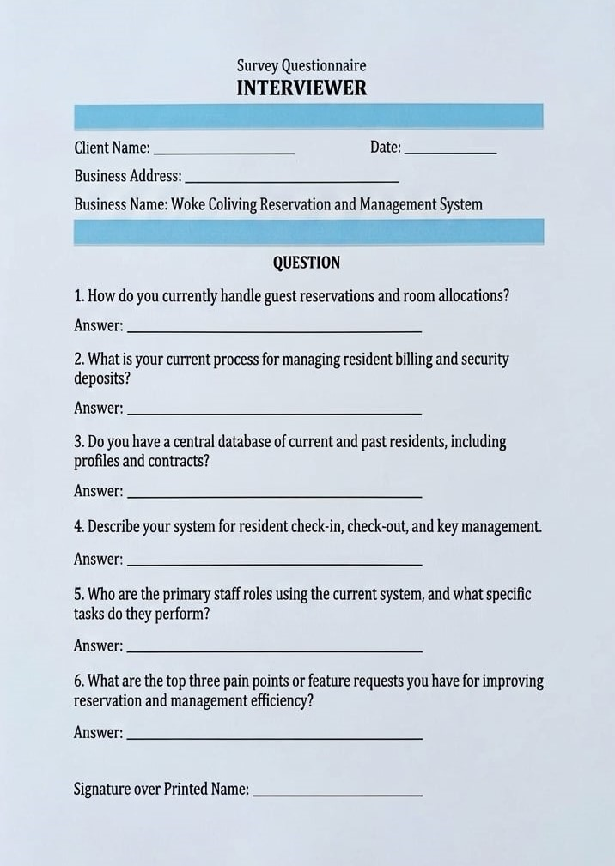
INTERVIEWER

